cADDITION UP TO 100
KS1 – 2002 Paper
1.
KS1 – 2003 Paper 1
2.
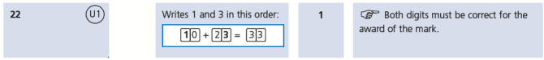
KS1 – 2004 Paper 1
3.
4.
KS1 – 2004 Paper 2
5.
KS1 – 2005 Paper 1
6.
33

KS1 – 2007 Paper 1
7.
KS1 – 2009 Paper 1
8.
KS1 – 2009 Paper 2
9.
KS1 – 2016 Paper - Arithmetic
10.
11.
12.
13.
14.
15.
KS1 – 2016 Paper - Arithmetic (Second)
16.
17.
18.
19.
20.

KS1 – 2017 Paper – Arithmetic
21.
22.
23.
24.
25.
26.
27.
28.
29.
KS1 – 2018 Paper – Arithmetic
30.
31.
32.
33.
34.
35.
36.
37.
KS1 – 2019 Paper – Arithmetic
38.
39.
40.
41.
42.
43.
44.
KS1 – 2022 Paper – Arithmetic
45.
46.
47.
48.
49.
50.
51.
52.

